Access to Equality:
Reproductive Justice in the United States
Institute of English and American Studies (IEAS)

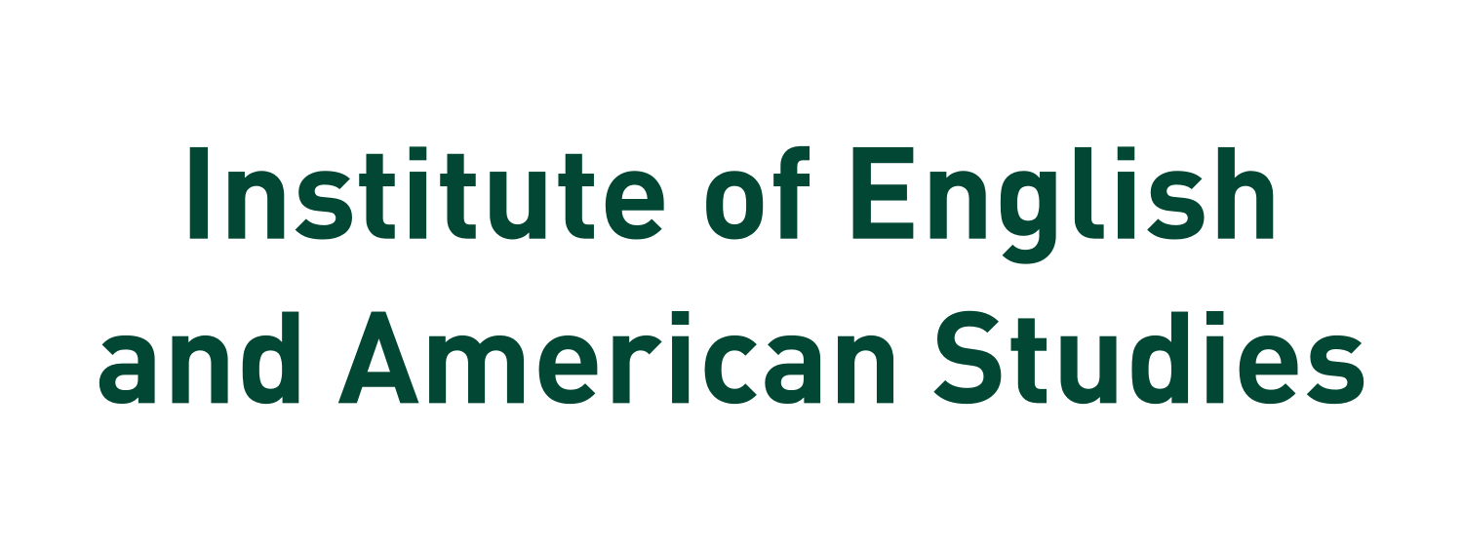

Access to Equality:
Reproductive Justice in the United States
Institute of English and American Studies (IEAS)
All sessions will take place in Studio 111, Registration and Coffee Breaks in Studio 109

Friday March 31, 2023

8:30 Registration
Studio 109
9.00 Conference opening
9.15-10.45 Reproductive (In)Justice in Health and Health Care
Chair: Ingrid Gessner
“‘Like a Shadow’: Patriarchal Religious Structures and Women’s Health”
Beth Williams Purcell (PhD candidate, Texas Christian University Fort Worth, Texas, USA)
“Nineteenth-Century Science of Surgery as Cure for the Greatest Curse”
Sigrid Schönfelder (speaking online, CET) (PhD, University of Passau, Germany)
“‘[T]he doctor said if I signed this paper they could help me’: Settler Colonialism and Impacts on the Reproductive Freedoms of Indigenous Women”
Nina De Bettin Padolin (speaking online, CET) (PhD candidate, University of Graz, Austria)
10.45-11.15 Coffee break
Studio 109

11.15-12.45 Keynote lecture:
“Reproductive Rights as a Site for a New Cold War” Andrea Pető (Central European University, Vienna)
Chair: Éva Mathey

12.45-14.00 Lunch break

14.00-16.00 The Legal and Political Legacies of Reproductive Justice
Chair: Beatrix Balogh
“Unsung Sheroes: The 14th Amendment at the Intersection of Race, Gender, and History”
Vanessa Vollmann (PhD, University of Passau, Germany)
“Protect and Control: Coverture’s Logics across Welfare Policy and Abortion Laws”
Clare Daniel (Administrative Associate Professor, Tulane University, New Orleans, Louisiana, USA) &
Karissa Haugeberg (Associate Professor, Tulane University, New Orleans, Louisiana, USA)
“The Road not Taken: The Republican Party before the War on Women”
Françoise Coste (speaking online, CET) (Professor, University of Toulouse)
“Legal Aspects of Post Mortem Procreation in the USA and Poland”
Maciej Rzewuski (speaking online, CET) (Associate Professor, University of Warmia and Mazury, Olsztyn, Poland and judge at the District Court in Olsztyn)
16.00-16.30 Coffee break
Studio 109
16.30-18.00 Representations and Activism in New and Old Media
Chair: Marie Dücker
“‘Can I train my two-months’ old to soothe himself to sleep?’: Gender, Class and Infant Care in American Cities as Reflected on Facebook Parental Forums”
Justyna Wierzchowska (speaking online, EST) (Associate Professor, University of Warsaw, Poland)
“Never Again: Ms. Magazine and Reproductive Justice”
Nicole Haring (PhD candidate, University of Graz, Austria)
“Drawing (on) Roe vs. Wade: Reproductive Justice in Feminist Underground Comix in the 1970s”
Małgorzata Olsza (speaking online, CET) (Assistant Professor, Adam Mickiewicz University, Poznań, Poland)
18.30-19.00 Cultural program
Live performance of Hungarian folk songs and Broadway musical pieces by Debrecen students with piano accompaniment
Studio 111
20.00 Conference dinner

Saturday, April 1, 2023

9.00-10.00 Portraits of Women in the Fight for and against Reproductive Justice
Chair: Imola Bulgozdi
“Meridel LeSueur: A Voice for Reproductive Justice of the 1930s”
Roberta Maierhofer (Professor, University of Graz, Austria)
“How Jane Roe became a ‘Pro-Life champion’”
Beatrix Balogh (Faculty, Pázmány Péter Catholic University, Budapest, Hungary)

10.00-10.30 Coffee break
Studio 109
10.30-12.00 Narrations of Reproductive Justice in Literature: Part I
Chair: Izabella Kimak
“Beyond the Norms: Reproductive Justice and Intersexuality in Select Fiction”
Parvathy Das (speaking online, GMT + 5:30) (Research Scholar, National Institute of Technology Calicut, India) &
Reju George Matthew (speaking online, GMT + 5:30) (Assistant Professor, National Institute of Technology Calicut, India)
“Four Faces of Reproductive Rights in Leni Zumas’s Red Clocks”
Barbara Miceli (speaking online, CET) (Assistant Professor, University of Gdańsk, Poland)
“Reimagining Reproduction and Biotechnology in US-American Environmental Fiction”
Ina Batzke (speaking online, CET) (Post-doctoral researcher and lecturer, University of Augsburg, Germany)

12.00-14.00 Lunch break

14.00-16.00 Narrations of Reproductive Justice in Literature: Part II
Chair: Elisabetta Marino
“A Subjectivity She Can Call Her Own: Law, Order, and the Maternal Experience in Celeste Ng’s Little Fires Everywhere”
Fulvia Sarnelli (speaking online, CET) (Assistant Professor, University of Messina, Italy).

“Damned If We Do, Damned If We Don’t: Narratives of Reproductive Control”
Sandra Tausel (speaking online, CET) (PhD candidate, University of Innsbruck, Austria)
“Reclaiming Control: Forms of Resistance in Contemporary Reproductive Dystopias”
Raluca Andreescu (speaking online, GMT+2) (Assistant Professor, University of Bucharest, Romania)

“Portrayals of Reproductive Rights Abuses and Embodiment in Contemporary Black, Chicana, and Native American Fiction”
Zsuzsanna Lénárt-Muszka (PhD, Instructor, University of Debrecen, Hungary)
16.00-16.30 Coffee break
Studio 109
16.30-17.30 Re-Mapping Publics in Reproductive Justice Activism
Chair: Christen Bryson
“Women’s Studies, Pregnant Academics, and the Climate of Change at US American Universities of the 1970s”
Abigail Fagan (speaking online, CET) (Assistant Professor, Leibniz Universität Hannover, Germany)
“Affect as an Act of Doing for Rewriting the Binary Distinctions Informing Liberal Conceptualization of ‘Human Rights’”
Erzsébet Barát (Associate Professor, University of Szeged, Hungary)

17.30 Conference closing

